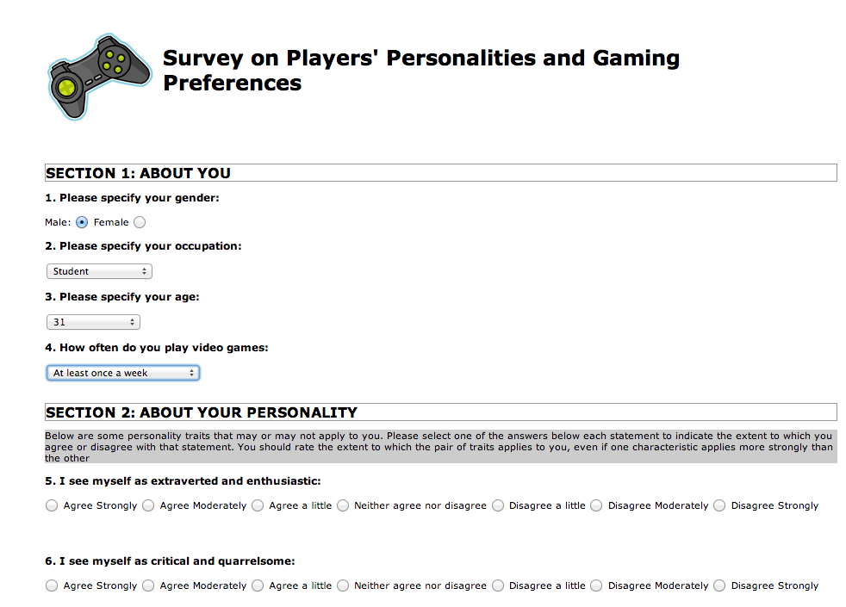

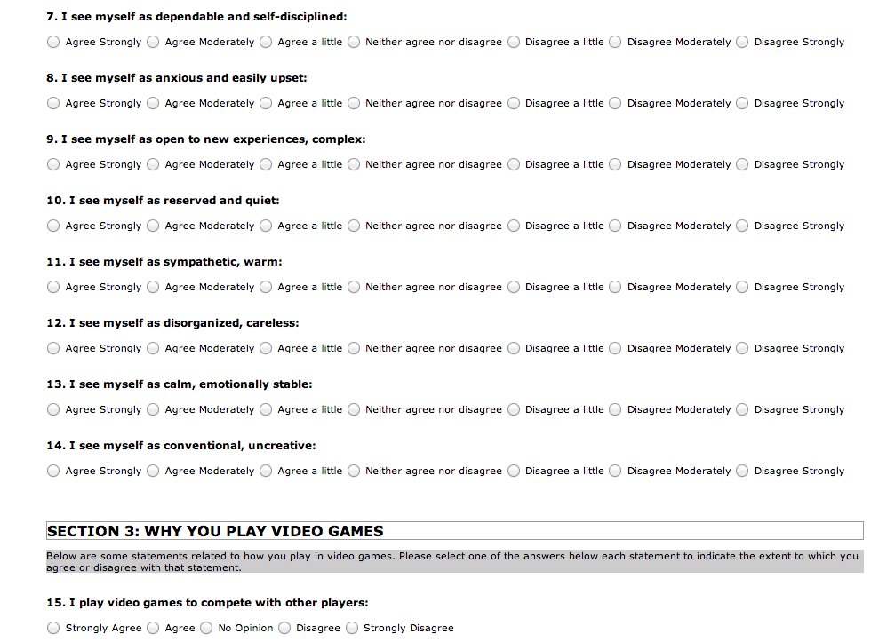

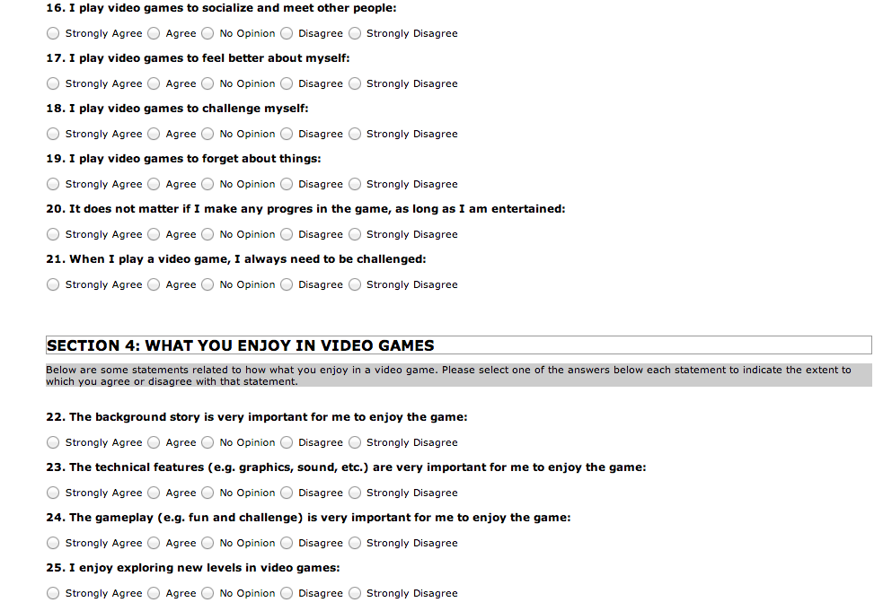

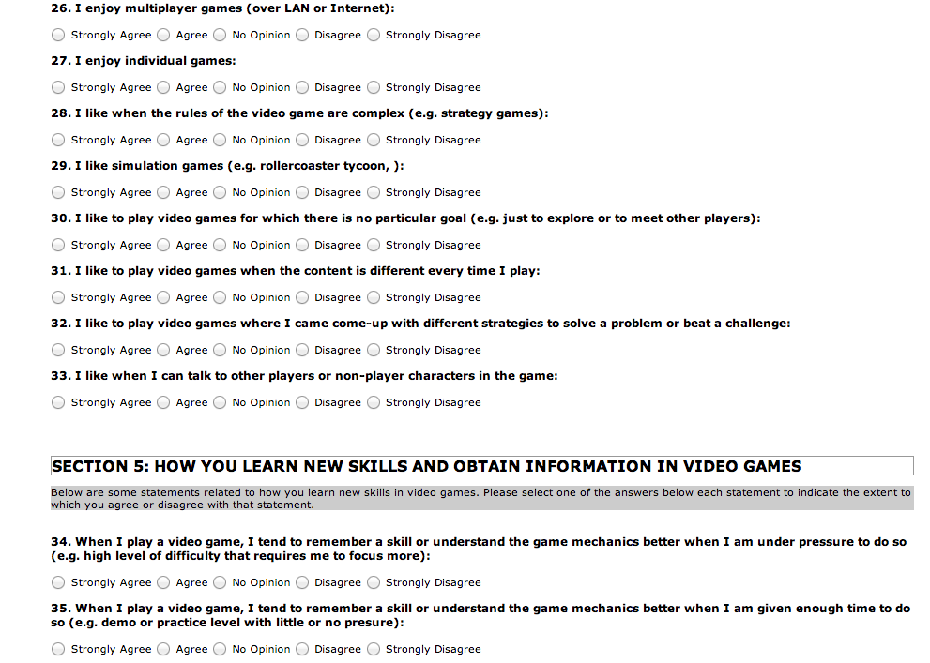

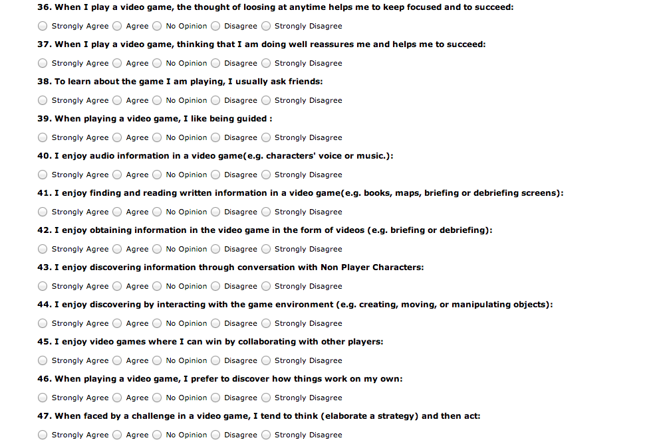

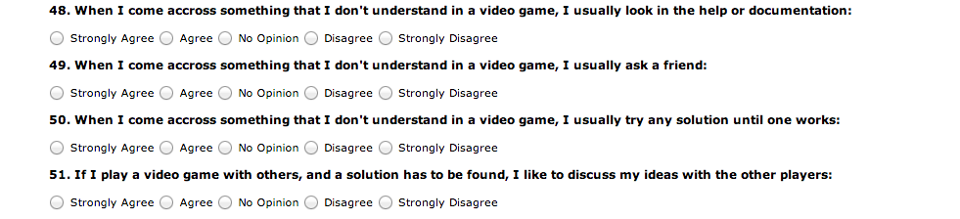

**Players’ personalities and gaming preferences**

The purpose of this survey is to obtain information how personalities and gaming preferences in different ages, genders, and occupation. This survey has 5 stages. 1st stage is about personal questions such as gender, age, etc. 2nd stage is about the personality of person who takes the survey. 3rd stage is about the reasons of playing video games. The 4th stage is why survey taker likes and enjoys playing video games. The last and 5th stage is how survey takers learn new skills and get information while playing video games.

First of all, I took the survey to make sure worded properly, clear to understand not ambiguous and vague questions used in this survey, and categorized very well. Also, the instrument is clear and no ambiguous. There are not double barreled questions in the survey. General questions to specific way. It asks survey takers general questions to warm up and then ask detail-oriented questions.

This survey’s majority questions are 7 Likert type scale and 5 Likert type scale. The 1st stage is 2 options like gender questions or more than 10 options questions like age. It is clear and user-friendly interface to be easy-to-use with online environment.

The strength of this survey the way survey has 5 different categories to distinguish each topic with specific questions. It is so clear and doesn’t confuse the survey takers. However, the weakness of this survey is that each stage has different Likert and it makes confuse the survey taker. The 1st stage has mixed likert scale, the 2. Stage is 7 Likert Scale, which has (Agree strongly, Agree moderately, Agree a little, Neither agree nor disagree, Disagree a little, Disagree moderately, Disagree strongly). The 3rd,4th, and 5th  stage is 5 Likert scale which has (Strongly agree, agree,

no opinion, disagrees, and strongly disagree.)

Another negative perspective of this survey there are 51 questions and it takes too much time to take survey for survey takers to finish it. Less than 51 questions would be better to ask.

Also, Question 18 and question 21 is so similar and almost same question to ask. It makes survey takers to be negative to finish rest of the questions.

Question 18 is, “I play video games to challenge myself.”

Question 21 is, “When I play a video games, I always need to be challenged.”

Hypothesis: personalities effects gaming preferences in different ages, genders, and occupation.

Research question: Does Personalities effects gaming preferences in different ages, genders, and occupation?

The target population is big since the stage 1 of this survey asks questions about gender, age, and occupation so that since online survey. The age range is 1-99, and gender options are female and male, and occupation has different 5 options, which are student, working, retired, working at home, and unemployed.

I think this survey is representative, but the occupation section should have other because there are other people, which are not able to answer that question.

Instrument is electronically find by this link online.

http://www.3delearning.com/surveys/players/questionnaire.php

The best method given the target population is online survey. In particular, in this century mail, telephone call, and go home by home to ask questions are not common and effective anymore. People don’t want to be bothered by calling, and knocking door by strangers. It also end up with Bradley effect since people just want to answer the questions they don’t care they are lying or not on the phone and knocked by door to get out of this situation. However, online environment is easy to answer and user-friendly interface is helping survey takers. Online environment you don’t force them to take survey, but phone and knocking door seems like forcing for them. Online and mail, phone call has a big gap to effect efficiency, validity, reliability, and accuracy on the survey results.

There are enough information provided for this instrument since 51 questions to be asked about personalities trait, video game types like strategic games, individual game playing to multiple player game playing, how often playing game rankings number is clear, asking about acquiring information and earning skills, enjoying, liking, and having fun while playing video games, the reason of playing video games. All of those points to cover and collaborate of study appear credible based on the instrument.