BEKIR MUGAYITOGLU

EDUCATIONAL STATISTICS TERM PROJECT

DR. GIBBS Y. KANYONGO

A Comparison of Language skills of EFL students between those who play video games and those who don’t play video games

1.) THE RESEARCH TOPIC

1.A.) RESEARCH QUESTIONS

1.B.) RESEARCH HYPOTHESIS

2.) REVIEW OF LITERATURE

2.A.) SIGNIFICANCE OF STUDY

3.) METHODS SECTION

3.A.) SAMPLE SIZE

3.B.) POPULATION

3.C.) VARIABLES

3.D.) DATA COLLECTION PROCEDURES

4.) DATA ANALYSIS

5.) CONCLUSIONS

5.1.) LIMITATION & FUTURE RESEARCH

APPENDIX A

APPENDIX B

REFERENCES

1. THE RESEARCH TOPIC

There are four skills to learn second language to communicate with native and non-native speakers effectively and efficiently. Listening, reading, writing, and speaking skills help second language learners to express themselves in daily life. However, most people complain about struggling with speaking skills in conversational proficiency and writing skills because of inhibitions about talking in the traditional class settings and writing essays, emails, letters. Foreign language learner peers are affecting them not to be comfortable, let them become self-conscious, and don’t want mistakes while speaking and writing second language. Therefore, teachers, instructors, tutors build their confidence and develop their language aptitude to let them play video games.

Researches have indicate that using computers and playing social, interactive, imbedded online chat rooms with multiplayers with microphone is an ample opportunity to practice speaking skills in non-threating environment.

Learners are more into the interactive conversation in the video game instead of face to face to practice target language with native and non-native speakers. Second language learners improve their cognitive skills and perceived and developed learning while interacting online with multiplayer. However, less research has been done on non-traditional computer- assisted language tools. I turn our attention to one specific form of interactive apps I-pad and I-phone games and their role as language learning tools.

Even though computer games have been criticized as being mindless entertainment with no educational value or content, and others argue that computer games have the potential to transform learning. Furthermore, research shows that computer games function as pedagogical tools that create active, interested and critical learners posits that computer games teach us about the learning process in ways that the traditional classroom environment does not. One particular pedagogical strategy stresses ”learning by doing” as a means for developing in depth knowledge of specific domain, rather than reading about concepts and expecting students to spontaneously develop deep knowledge. Students begin to master domain specific concepts, progressing from novice to intermediate level, when they participate in situated learning activities. Games transform the learning process from being a passive task to one in which individuals engage in the experience of learning. Computer games supply authentic environments for learning, complete with ample opportunities for students to develop and test their knowledge. We believe that learning that occurs in the virtual world can be transferred to learning in the real world. Therefore, we explore the novel application of computer games as a language-learning tool and propose a method of evaluation for computer games that support second language acquisition.

1.A.) RESEARCH QUESTIONS

1) Are there mean differences in language skills of EFL (English as a Foreign Language) students (as measured by the combination of speaking skills and writing skills) between those who play video games and those who don’t play video games?

2) Are there significant mean differences in speaking skills of EFL (English as a Foreign Language) students between those who play video games and those who don’t play video games?

If so, which groups differ?

Does playing video game influence speaking skills of second language learners?

3) Are there significant mean differences in writing skills of EFL (English as a Foreign Language) students between those who play video games and those who don’t play video games?

If so, which groups differ?

Do playing video game influence writing skills of second language learners?

1.B.) RESEARCH HYPOTHESIS

1) There are mean differences in language skills of EFL (English as a Foreign Language) students (as measured by the combination of speaking skills and writing skills) between those who play video games and those who don’t play video games.

2) There are mean differences in speaking skills of EFL (English as a Foreign Language) students between those who play video games and those who don’t play video games.

3) There are significant mean differences in writing skills of EFL (English as a Foreign Language) students between those who play video games and those who don’t play video games.

2.) REVIEW OF LITERATURE

2.A.) SIGNIFICANCE OF STUDY

This study is really important in this century since technology is great scaffolding for second language learners. “We believe that learning that occurs in the virtual world can be transferred to learning in the real world.” (Rankin, Gold, & Gooch, 2006).

The video game has a chat section that allows foreign students to meet with native speakers, acquire new vocabulary, reading comprehension, as well as English translation skills, and conversational skills. In turn, native speakers have a chance to learn about other cultures. Video games like this bring foreign language students and native speakers closer. Interactive video games for language learning could be leading positive correlation output in order to learn second language for foreign language students. ”Games transform the learning process from being a passive task to one in which individuals engage in the experience of learning.” (Rankin, Gold, & Gooch, 2006).

3.) METHODS SECTION

Using a MANOVA analysis, I randomly assign language students to two groups. EFL (English as a foreign lan Students those who play video games will experimental group and EFL students those who don’t play video games will compromise the control group.

I use MANOVA analysis for this project to analyze writing and speaking for Quantitative Analysis. Students who play English fun and are enrolled in an EFL class will comprise the test group. Students will be randomly assigned to each group. I will let them take a pre test using the speaking and writing skills tool to test overall spoken English and writing proficiency for both groups of students. Participants in the test group will download English fun apps to play English fun video game. To address the issue of learning how to play the game, I hosted a 2 hours tutorial session to review the basics of game play during the first week of game play. Sessions explained in students’ native language in which is Turkish. I covered the following topics: the story of game and objects role. Once students have reached level 2, students will be encouraged to play English fun for a minimum of 4 hours per week for the next 8 weeks. After 8 weeks, students data will be collected for each player and student-initiated discourse parsed for speaking skills. Using an MANOVA test for the two groups of participants, results will be analyzed for a significant increase in target language proficiency skills. I administered a post-assessment using the speaking and writing assessments tool for each student. In addition, students in the test group will complete a questionnaire evaluating students’ perception of English fun as a computer assisted learning tool. The results of our data analysis will be used to inform design decisions of subsequent experimental studies. Experiment over all took 1 (4 months) semester to collect the data.

3.A.) SAMPLE SIZE

The sample size found out which G\*Power, Effect size is 0.3, alpha err prob 0.05, and power is 0.8. After calculating the G\*Power the results indicates that sample size needed 278 students. (Appendix A). There are more than what is needed in this study that there are 338 students in the experimental group and 347 students in the control group.

3.B.) POPULATION

My target population is in this study undergraduate English as foreign language preparation 1-year program volunteer students at one of private Universities in Turkey. The sample size found out which G\*Power, Effect size is 0.3, alpha err prob 0.05, and power is 0.8. After calculating the G\*Power the results indicates that sample size needed 278 students. (Appendix A). There are more than what is needed in this study that there are 338 students in the experimental group and 347 students in the control group.

3.C.) VARIABLES

In my study, there are two groups, experimental group and control group. Experimental group is ESL students those who play video games and Control group is EFL student who don’t play video games. The dependent variables are writing and speaking skills. The independent variable is two groups. The independent level of groups is experimental group and control group. Writing and speaking variables are measured to take pre-test and post-test. Firstly, students are taken a pre-test to use their speaking test tool to test overall spoken English proficiency for both groups of students and writing test tool to test overall written English proficiency for both groups.

Participants in the experimental test group downloaded English fun apps to play English fun video game. To address the issue of learning how to play the game, I hosted a 2 hours tutorial session to review the basics of game play during the first week of game play. Sessions explained in students’ native language in which is Turkish. I covered the following topics: the story of game and objects roles. Once students have reached level 2, students will be encouraged to play English fun for a minimum of 4 hours per week for the next 8 weeks. After 8 weeks, students’ data collected for each player and student-initiated discourse parsed for speaking skills. Using an MANOVA test for the two groups of participants, results will be analyzed for a significant increase in target language proficiency skills. I administered a post-assessment using the speaking and writing assessments tool for each student.

3.D.) DATA COLLECTION PROCEDURES

I connected to mention about my study one of the private University in turkey to collect data. After approved by the president by University, I was soliciting student volunteers from one of the private University English as a foreign language preparation 1-year program in Turkey. In order to measure their speaking and writing skills, they took a pre and post assessment and experimental group played video game. I let them take a pre test using the speaking and writing skills tool to test overall spoken English and writing proficiency for both groups of students in which are experimental and control groups. Experimental group is ESL students those who play video games and Control group is ESL student who don’t play video games. After experimental group play video game, I let them both group to take a post-assessment using the speaking and writing assessments tool for each students. After collecting data, it is ready to run analysis.

4.) DATA ANALYSIS

Before I start doing statistical analysis, I check for missing data, we noticed that the number of missing data is 9. I believe the reason they are missing at random. I decided the delete this cases because the missing data is not bias our analysis. Next, I checked for outliers and I noticed that just a few cases are acting differently. Since I want to make accurate analysis and don’t change the data I decided to keep them.

Because of the Box’s test is not significant p >.149, I will check out Wilks’ Lambda criteria. According to the Multivariate Tests figure indicates that .595 group category is not significantly differs for the combined dependent variable. According to the Univariate ANOVA Summary table indicates (.981 and .327) group is not significantly affects speaking and writing skills.

A one-way multivariate analysis of variance was conducted to determine group differences in speaking skills and writing skills. MANOVA results revealed no significant differences among the group on the dependent variables, Wilks’ Λ = .998, F(2, 682) = .520, p > .001, eta^2= .002. Analysis of variance was conducted on each dependent varaible as a follow-up test to MANOVA.Differences in speaking skills were not significant, F(1,683) = .001, p= .981, partial eta^2=.000. Also, differences in writing skills were not significant, F(1, 683) = .961, p=.327, partial eta^2= .001. Post hoc tests are not performed for Group because there are fewer than three groups. There are two groups in this study that Experimental group and Control group.

Table 1. Unadjusted means for Speaking and Writing Skills by groups

Group Mean Std. Deviation N

Speaking Experimental group 14.19 4.30 338

Control group 14.18 4.14 347

Total 14.18 4.22 685

Writing Experimental group 46.22 10.88 338

Control group 47.07 11.84 347

Total 46.65 11.38 685

Experimental group: EFL students those who play video games

Control group : EFL students those who don’t play video games

Table 2. Multivariate tests for Speaking and Writing Skills by groups

Effect Value F Hypothesis df Error df. Sig. Partial eta squared

Intercept Pillai’s Trace .958 7707.149b 2.000 682.000 .000 .958

Wilk’s Lambda .042 7707.149b 2.000 682.000 .000 .958

Hotelling’s Trace 22.602 7707.149b  2.000 682.000 .000 .958

Roy’s Largest Root 22.602 7707.149b 2.000 682.000 .000 .958

Group Pillai’s Trace .002 .520b 2.000 682.000 .595 .002

Wilk’s Lambda .998 .520b 2.000 682.000 .595 .002

Hotelling’s Trace .002 .520b  2.000 682.000 .595 .002

Roy’s Largest Root .002 .520b 2.000 682.000 .595 .002

1. Design: Intercept + Group
2. Exact statistic

Table 3. Univariate ANOVA Summary Table

Source Dependent variable Type III Sum of Squares df Mean square F Sig. Partial Eta Squared

Corrected model Speaking .11a  1 .001 .981 .000

Writing 124.569b  1 .961 .327 .001

Intercept Speaking 137873.494 1 7727.08 .000 .919

Writing 1490540.13 1 11501.73 .000 .944

Group Speaking .011 1 .001 .981 .000

Writing 124.56 1 .961 .327 .001

Error Speaking 12186.69 683

Writing 88511.81 683

Total Speaking 150083 685

Writing 1579792 685

Corrected Total Speaking 12186.7 684

Writing 88636.38 684

5.) CONCLUSIONS

I have applied one of the most popular apps English fun video game to function as a language learning tools for EFL students. I offered a methodology for evaluating English Fun as a second language acquisition pedagogical tool for EFL students. English fun video game doesn’t help EFL students to acquire second language speaking and writing skills and to identify the appropriate pedagogical strategy that enables students to leverage the benefits of gaming. After the result of analysis shows that running the MANOVA analysis data we collected we conclude that English fun video games don’t help EFL students to acquire second language speaking and writing skills. One of the reasons why the result it might be because the players were interacting with other non-native speakers.

5.A.) LIMITATION AND FUTURE RESEARCH

I applied this study for Turkish students, but it might be better to expend the experiment with players of other nationalities. Also, as a future research we can try to use better application with is more user-friendly in our experiment.

Appendix A.

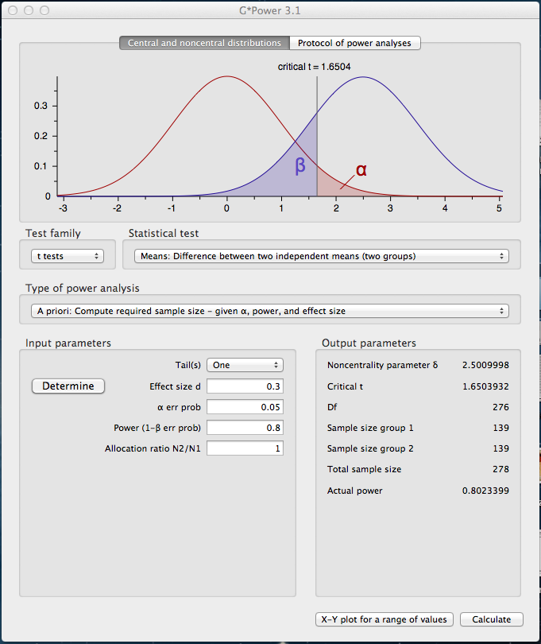

Appendix B. Box’s Test of Equality of Covariance Matrices

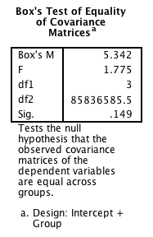

REFERENCES

CHERNY, L. 1999. *Conversation and Community: Chat in a Virtual World*. CSLI Publications.

Rankin, Y., Gold, R., & Gooch, B. (2006). Evaluating interactive gaming as a language learning tool. In *Conference proceedings of SIGGRAPH 2006,* Boston, MA. Retrieved from <http://webhome.cs.uvic.ca/~bgooch/Publications/PDFs/a44-rankin.pdf>