Bekir Mugayitoglu

Independent Study

If we build a better educational programming language curriculum with strategic insight drawing from right pedagogy, students will learn better

Fall 2014

Dr. Carbonara

Computational thinking and computational creativity is the most beneficial source to give children priceless power to make, create, invent and carry out projects with technological devices using through programming languages.

However, do we teach computational thinking and computational creativity students? We would like to, but we don’t since teachers don’t know how to start, how to teach, and what curriculum to use.

The aim of this independence study is to design programming Curriculum for ages of 5 to up. I feel that this will greatly benefit my research. There are several programming languages to integrate in the classroom setting, but it is important to pick right tools for the right time for creative computing. In this independent study, I use Scratch JR, Hopscotch, and MIT Scratch that are a free computer and tablet based programming languages developed by different company and schools. This independence study is the collection of ideas, strategies, and activities for younger programmers to creative computing experience using the Scratch JR, Hopscoth, and MIT Scratch.

My independent study is designed to build Curriculum activities with Scratch JR, Hopscotch, and MIT Scratch. Further, I want to begin to test the hypothesis that If we build a better educational programming language curriculum with strategic insight drawing from right pedagogy, students will learn better K through 8 grade students.

**Hypothesis:** If we build a better educational programming language curriculum with strategic insight drawing from right pedagogy, students will learn better

**Research question:** Do students learn better if we build a better educational programming language curriculum with strategic drawing from right pedagogy?

**Literature of Review**

Papert, S. (2005). Teaching children thinking. *Journal of structural learning*,*4*(3), 219-230.

“Technology and education,” often means creating gadgets to teach the same thing with a little bit twist. Skinner box experiment shows that children are acting like pigeons to have rote learning. The process of learning is that child is involving it, brainstorming, coming up with the ideas, and experiencing with output. After getting results, share with others to criticize what he came up with.

Thinking, playing, and learning are the occupational activities for kids to apply in their daily life. However, they don’t. We don’t mention about those things. What we do instead of those things is that we ask them numbers, grammar, and the French Revolution. The question is that why don’t we make them think, learn, and play?

Resnick, M. (2007, June). All I really need to know (about creative thinking) I learned (by studying how children learn) in kindergarten. In *Proceedings of the 6th ACM SIGCHI conference on Creativity & cognition* (pp. 1-6). ACM.

Kindergarten is the most significant experience of educational life in people life. Kids have a lot of activities like; sharing their stories, drawing their house pictures, and building places with their friends. Kindergarten was the place kids were creative than rest of school time. However, it changed even in kindergarten there is no creative and innovative activities for kids.

Creative thinking process is iterative and self-directed process. There are six steps to teach learners to develop their creative thinking skills with kindergarten style learning to extend all ages not just kindergarten students. Those steps are Imagine, Create, Play, Share, Reflect and then imagine again.

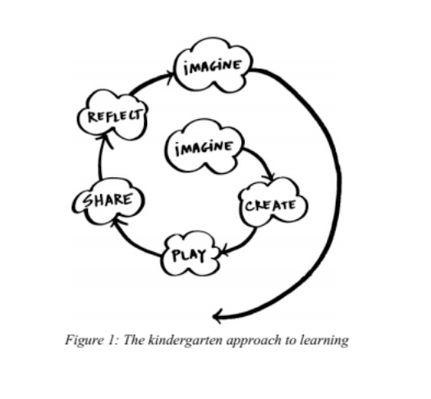

Dr. Carbonara and I will meet weekly to discuss Curriculum design process and I will teach K-8 grader kids in this fall semester to apply. I will consult with him to design the lessons to teach the Kodable, ScratchJR, Hopscotch, and MIT Scratch. The final deliverable for this three-credit independent study is a paper that will: 1) increase the literature review on problems solving activities such as debugging, creating, and making, 2) design, develop and assess the teaching of a coding technique to K through 8 grades and 3) provide an opportunity to advance my thoughts toward my dissertation.

**References:**

Papert, S. (2005). Teaching children thinking. *Journal of structural learning*,*4*(3), 219-230.

Resnick, M. (2007, June). All I really need to know (about creative thinking) I learned (by studying how children learn) in kindergarten. In *Proceedings of the 6th ACM SIGCHI conference on Creativity & cognition* (pp. 1-6). ACM.