**Statistics II**

**Bekir Mugayitoglu**

**Data Analysis Project:**

**Unemployment rate**

**and**

**The number of Undocumented immigrants**

**INTRODUCTION**

Before discussing what the correlation between unemployment rate and the number of undocumented immigrants entered illegally, I want to present an overview of the history of laws on immigration in the US. The supreme document of the US, the Constitution does not make mention of the word immigration. However, the fact that the Constitution does not use the word immigration does not mean that it lacks the concept of immigration.

The federal government reflected popular sentiment in restricting immigration in the late nineteenth and early twentieth centuries. Slaves forcefully brought from Africa were the first immigrants in America, but Congress banned importation of slaves in 1808. Otherwise, the United States maintained an open door policy on immigration until 19th century. There were large influxes of immigrants from Europe during that period. From 1836 through 1914, more than 30 million Europeans migrated to the US. In particular, Europe’s mid-century agricultural crisis drove waves of German and Irish peasants to the United States in the 1840s and 1850s. In the nineteenth century, the migration of the Chinese to America increased, too, with the California Gold Rush of 1849. However, to the end of the century, there were attempts to curb the coming of the Chinese to America. The Page Act of 1875 was the first federal immigration law that prohibited the entry of “undesirable” immigrants. This category included individuals from Asia who came to America as contract laborers, ex-convicts, or females that could potentially be involved in prostitution.

**IMMIGRATION FROM MEXICO**

The history of the Mexican migration to America goes back to the war between the US and Mexico in 1848. In the aftermath of this war and the Gadsden Purchase, many Mexicans found themselves living in the territory of a new country, the US. For a long time, the US government exempted Mexicans from immigration restrictions that it put on other nationalities, especially, those who came from Europe. The reason for these exemptions was that Mexicans made up a cheap labor force that growers in the southwest depended on. Barriers to the migration of Mexicans came about during the Great Depression, when many Americans were unemployed and anti-immigration sentiments grew stronger. After World War Two, the fast economic growth and the shortage of labor in America opened up new opportunities for Mexican immigrants. These favorable conditions came to an end in 1954 when the US government implemented Operation Wetback deporting over a million undocumented immigrants back to Mexico. In 1986 Congress made it illegal to knowingly hire illegal immigrants, but it also granted amnesty to certain immigrants who entered the U.S. before 1982 and created a citizenship path for certain agricultural workers. Since then border immigration has been of the most troubling problems that government has not been able to tackle effectively. In 2012, for the first time in the history, the migration trend reversed and more Mexicans went back to Mexico from America.

This project is about the correlation between unemployment rate and the number of undocumented immigrants entered United Stated illegally

Based on the Department of Homeland Security estimates in 2009, unauthorized immigrant population living in the United States decreased to 10.8 million in January 2009 from 11.6 million in January 2008. Between 2000 and 2009, the unauthorized population grew by 27 percent. (Hoefer,Rytina, and Baker.2010).

There are several reasons undocumented immigrants entered numbers change in the United States. Job opportunities and law enforcement. Also, Illegal immigrants are filling gaps in fields where there is a low job demand among Americans workers because of a low pay.

**REVIEW OF LITERATURE**

The Pew Hispanic Center estimated in December 2012 that there were 11.1 million unauthorized immigrants living in the U.S. as of March 2011, unchanged from the previous two years and a continuation of the sharp decline from its peak of 12 million in 2007. This decline has been the first significant decrease following two decrease following two decades of growth up to 2007. (Passel and Cohn 2012).

Unemployment Rate in the United States decreased to 7.60 percent in March of 2013 from 7.70 percent in February of 2013. Unemployment Rate in the United States is reported by the Bureau of Labor Statistics. Historically, from 1948 until 2013, the United States Unemployment Rate averaged 5.81 Percent reaching an all time high of 10.80 Percent in November of 1982 and a record low of 2.50 Percent in May of 1953. In the United States, the unemployment rate measures the number of people actively looking for a job as a percentage of the labor force. (Funtos, 2013)

Undocumented immigrants entered U.S. to the U.S. has stopped and possibly reversed since several years. This decreased due to either increased law enforcement or fewer job opportunities.

The Pew Hispanic Center estimated that the population of illegal immigrants grew from 1990 to a high of 11.9 million in 2006 plus another 1.1 million persons who are believed to be undercounted in the published estimates, and then dropped during the following recession. The change was noticeable by 2008, and was sharply down by 2010.

If considering the 2007 data for immigrant migration by the United States rate, the highest numbers of immigrants entered between 2000 and 2007 during a high demand for construction labor with real estate market growth. Then due to the economic slow down in late 2007, the number of illegal immigrants decreased.From the data of the Current Population Survey (CPS), which is collected monthly by the Census Bureau follows that there is a clear evidence that the illegal population has declined significantly between 2008- 2011. The evidence indicates that since hitting a peak in the summer of 2007 the illegal population may have declined by almost 14 percent. A decline in the illegal population is caused by two factors like US economy and US enforcement. The decline is caused by fewer immigrants coming and more returning home.

**THE RESEARCH TOPIC**

This selecting topic was designed to address specific research question below:

1. Is there a correlation between the US unemployment rate and the number of undocumented immigrants entering the country annually?

**METHODS &** **DATA ANALYSIS**

**Design**

The data was collected by two governmental organizations; U.S. Bureau of Labor Statistics and U.S. Department of Homeland Security. Between 1982 to 2012 Unemployment rate taken by U.S. Bureau of Labor Statistics and Estimated number of undocumented entered U.S. illegally from U.S. Department of Homeland Security.

After taking data, the researcher entered data into the statistical software SPSS for analysis. The Research shows the correlation between unemployment rate and the number of Undocumented immigrants entered America illegally. Unemployment rate*M* = 6.371, with a total standard deviation of, SD = 1.69. The number of Undocumented immigrants entered U.S. illegally M= 911.273. 48 and SD=376786.61.

Analysis of the results from the Correlation showed a significant correlation betweenunemployment rate and the number of undocumented immigrants entered illegally, *p* <.05, when alpha was set at *r* =-.45. There is a significance relationship between two variables.

***Sample***

G*power showed what sample size the researcher needs for achieving power of .80 and a medium effect size of .25. G*power told the researcher what minimum number of 29 years required to achieve the requisite statistical power (see Appendix A).

**Correlations**

**Table 1.**

**Correlations Among Study Variables**

**Unemployment # of Undocumented Immigrants**

**Rate Entered U.S. illegally**

**Unemployment rate ------ -.45**

**The number of Undocumented -.45 ------**

**immigrants entered U.S. illegaly**

**p < 0.05 level.**

**Appendix B.**

**RESULTS**

Between 1982 to 2012 data of Correlation between Unemployment rate and the number of Undocumented immigrants are showing us there is a negative relationship. *r* =-.450. There is significant relationship between unemployment rate and the number of undocumented immigrants entering U.S. illegally, p<.05 and also there is an inverse relationship. When unemployment rate increases, undocumented immigrants entered U.S. illegally decreases. When unemployment rate decreases, undocumented immigrants entered U.S. illegally increases.

**REFERENCES**

Michael Hoefer, Nancy Rytina, and Bryan C. Baker. ( 2010). Estimates of the Unauthorized I Immigrant Population Residing in the United States: January 2009

<http://www.dhs.gov/xlibrary/assets/statistics/publications/ois_ill_pe_2009.pdf>

Jeffrey Passel and D’Vera Cohn. (2012). Unauthorized Immigrants: 11.1 million in 2011

<http://www.pewhispanic.org/2012/12/06/unauthorized-immigrants-11-1-million-in-2011/>

Nuno Fontes. (2013). U.S. Unemployment rate down to 7.6 % in March

<http://www.tradingeconomics.com/united-states/unemployment-rate>

Appendix A

Results from G-Power Analysis

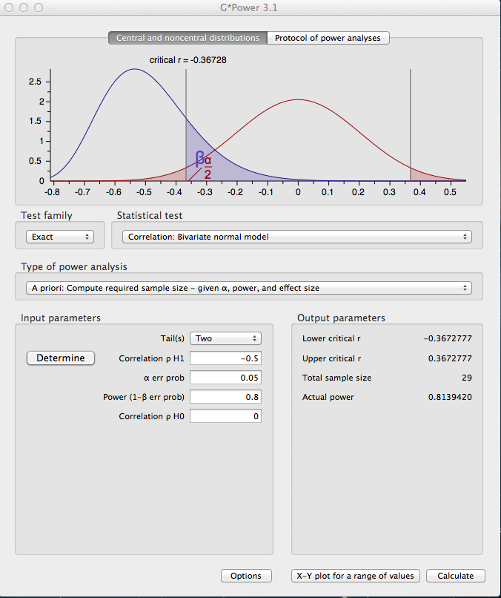

**Appendix B**

**Correlation**

